VOIP lab experiment#16
Creating an IVR in the PBX

Installation and Repair of Telecommunications Equipment

Name of student:________________
Group Number:_________________
Date:_________________________

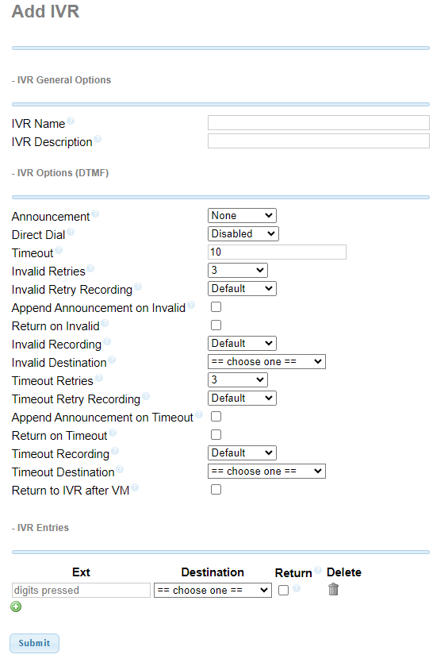
The purpose of the lab is to create a IVR (Interactive Voice Response) for the company in the PBX.
- Enter the IVR name
- Enter the IVR description
- Announcement input your department in your diagram and put the audio you created earlier
- Invalid destination IVR
- Timeout destination IVR

IVR entries
EXT 1: Queue department name
EXT 2: Ring group department name
EXT 3: Queue department name
EXT 4: Ring group department name

